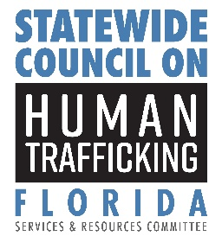
Services and Resources Committee Agenda

January 16, 2026
2:00 p.m.

Chair:
Secretary Taylor N. Hatch, Florida Department of Children and Families (DCF)

Committee Members:
Secretary Shevaun Harris, Florida Agency for Health Care Administration (AHCA)
State Surgeon General Joseph A. Ladapo, Florida Department of Health (DOH)
Secretary Matt Walsh, Florida Department of Juvenile Justice (DJJ)
Commissioner Anastasios Kamoutsas, Florida Department of Education (DOE)

Welcome  Roll Call  Approval of Minutes and Opening Remarks  Operation Home for the Holidays  Survivor Mentorship  DOE Human Trafficking Awareness Training  Public/Agency Comments  Closing and Next Meeting | Jonathan Stephens, DCF  Jonathan Stephens, DCF  Jonathan Stephens, DCF  Senior Inspector Mario Price, USMS  Kelly Posze, Her Song  Vice Chancellor Peggy Aune, DOE  Committee Members  Jonathan Stephens, DCF

